Girlguiding policy briefing: Online harms
What we believe
As the leading charity for girls and young women in the UK, we believe that the Online Safety Bill must protect girls and young women online. In its drafted form, it does not go far enough. We recommend that the Online Safety Bill recognises:
- the disproportionate impact that online abuse and harassment has on girls and young women, especially girls of colour, LGBQT+ girls, and disabled girls.
- body image and appearance related harms, and the devastating impact this has on girls’ and young women’s mental health and wellbeing.
- the link between online harms and offline harm targeted at girls and young women.
What we know
Our 2021 Girls’ Attitudes Survey shows seven in ten (71%) girls and young women aged 7-21 have experienced some form of harmful content while online in the last year. This includes half (49%) aged 7-10, rising to almost three quarters (73%) aged 11-16, and nine in ten (91%) 17-21s.
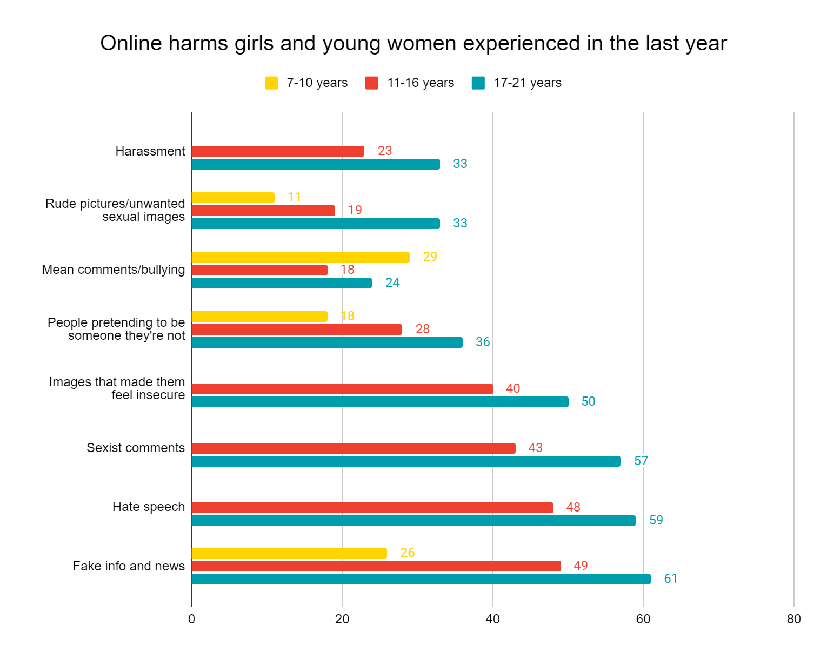
These harms include: fake info and news; hate speech; sexist comments; images that made them feel insecure; people pretending to be someone they’re not; mean comments/bullying; rude pictures/unwanted sexual images; harassment; pressure to share images of themselves they’re not comfortable with; and cyberstalking.
The Online Safety Bill: what we need
- Recognition within the text of the Bill that online abuse disproportionately impacts girls and young women especially those with multiple protected characteristics
- Better prevention to address harassment and abuse of girls and women online, and for this to take an intersectional approach, recognising the experiences of girls of colour, LGBTQ+ girls, and disabled girls.
- Effective age-verification controls to ensure children aren’t accessing inappropriate and harmful content online.
- Recognition of the benefits and risks of increased time spent online because of the pandemic and what this means for girls’ and young women’s safety online.
- Body image and appearance related harms should be included in the duty of care and tackled within the Online Safety Bill
- Altered images are labelled clearly and consistently on social media posts and advertising
- Weight-loss and appearance improving ads are not shown to under 18s

The Bill must be accompanied by effective Relationships, Sex and Health Education covering consent, unhealthy relationships and sexual harassment for all children and young people as well as action to tackle offline violence against women and girls (VAWG) including public sexual harassment.

What we’re doing
Girlguiding delivers a range of activities for girls to mitigate the impact of online harms:
- The Media Critic interest badge for Guides allows them to develop media literacy
- The Free Being Me peer education programme helps girls grow body confidence and challenges unhealthy beauty ideals. It encourages girls in Brownies and Guides to challenge social image myths and reframe the ways they think about their bodies so that they are able to articulate positive things about them and value them for more than just how they look.
- The Breaking Free peer education resource empowers young people to enjoy their hobbies, gain the skills they’re interested in and help bring about a world where nobody feels trapped by gender stereotypes. Through this resource, girls can develop skills in assertiveness, cultural awareness and media literacy.
- The Feel Good Skills Builder allows girls to develop body confidence, self-esteem and resilience.

About Girlguiding
Girlguiding is the leading charity for girls and young women in the UK, with nearly a third of a million members. We’re active in every part of the UK with more than 25,000 groups meeting weekly, powered by over 80,000 volunteers. We offer girls and young women a space where they can be themselves, have fun, build brilliant friendships, gain valuable life skills and make a positive difference in their communities. We build girls’ confidence and raise their aspirations. We give them the chance to discover their full potential and encourage them to be a powerful force for good. We run Rainbows (4–7 years), Brownies (7–10 years), Guides (10–14 years) and Rangers (14–18 years).

Contact details
Leah Widdicombe, External Affairs Officer
Girlguiding
17-19 Buckingham Palace Road
London
S1W1 0PT
Leah.Widdicombe@girlguiding.org.uk
Website| Facebook | Instagram | Twitter

Annex
Since 2009, Girlguiding has given girls and young women a platform to speak out on the issues that matter to them through the Girls’ Attitudes Survey, our flagship research asking girls and young women how they feel about their everyday lives. This survey, now in its 13th year, asked over 2,000 girls and young women aged 7 to 21, both inside and outside of guiding, how they feel about the specific and emerging pressures facing them today, and what these mean for their happiness, wellbeing and opportunities in life.

Online abuse and bullying
- 48% aged 11-16 and 59% aged 17-21 have seen hate speech online in the last year
- 29% aged 7-10 have experienced mean comments online in the last year
- 18% aged 11-16 and 24% aged 17-21 have experienced bullying online in the last year Bullying. This is higher for LGBQ girls and young women (29% compared to 20% who are straight)
- 43% aged 11-16 and 57% aged 17-21 have experienced sexist comments or ‘jokes’ online in the last year. LGBQ girls and young women are more likely to experience this (72% compared to 44% who are straight)

Sexual harassment
- 23% aged 11-16 and 33% aged 17-21 have experienced harassment (e.g. unwanted messages or receiving threats. This is higher for LGBQ girls and young women (42% compared to 24% who are straight). Disabled girls are also more likely to be harassed online (40% compared to 25% without disabilities)
- 18% aged 7-10, 28% aged 11-16 and 36% aged 17-21 have experienced people pretending to be someone they’re not online in the last year
- 11% aged 7-10 have seen rude pictures online in the last year
- 19% aged 11-16 and 33% aged 17-21 have been sent unwanted sexual images online in the last year
- 9% of girls aged 13-16 have felt pressure to share images of themselves that they’re not comfortable with. This increases to 19% for 17-21s.
- 11% aged 11-21 have experienced cyberstalking online in the last year

Appearance pressures
    - 22% aged 7-10 and 51% aged 11-21 have felt self-conscious on video calls
    - 40% aged 11-16 and 50% aged 17-21 have seen images online in the last year that made them feel insecure or less confident about themselves.
    - Girls and young women aged 11-21 say images online make them feel insecure because they all show the same ‘perfected look’ (78%), they feel pressured to look more like them (66%), they’re unrealistic (60%), they all show the same body type (52%), and they don’t look like the people in them (45%).

Girlguiding (September 2021) Girls’ Attitudes Survey 2021 girls-attitudes-survey-2021-report.pdf (girlguiding.org.uk)
In the Girls’ Attitudes Survey we ask about gender identity separately from sexual orientation. This is why we have only referred to lesbian, gay, bisexual, queer or questioning here. Trans and non-binary girls and young women are still included in the survey.

