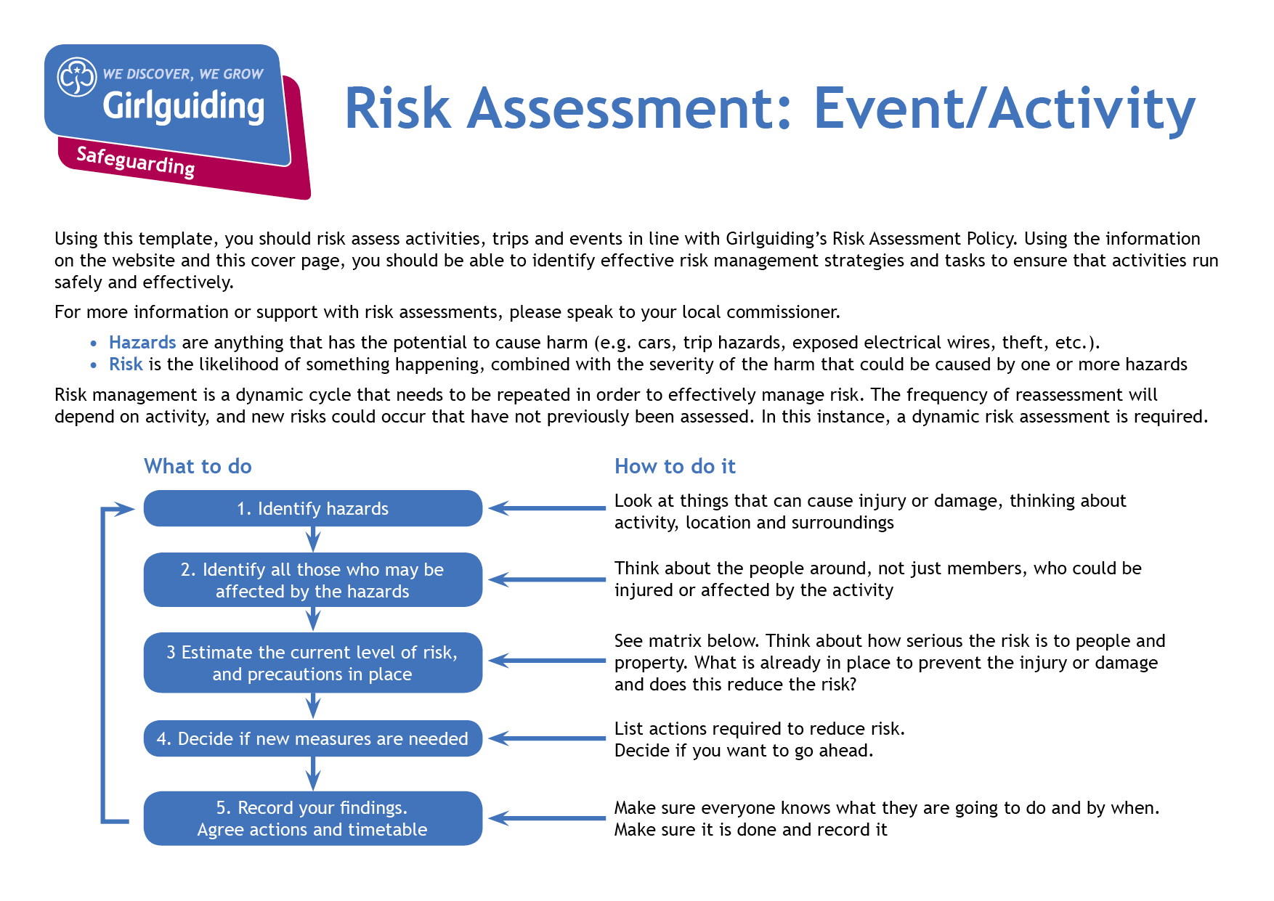
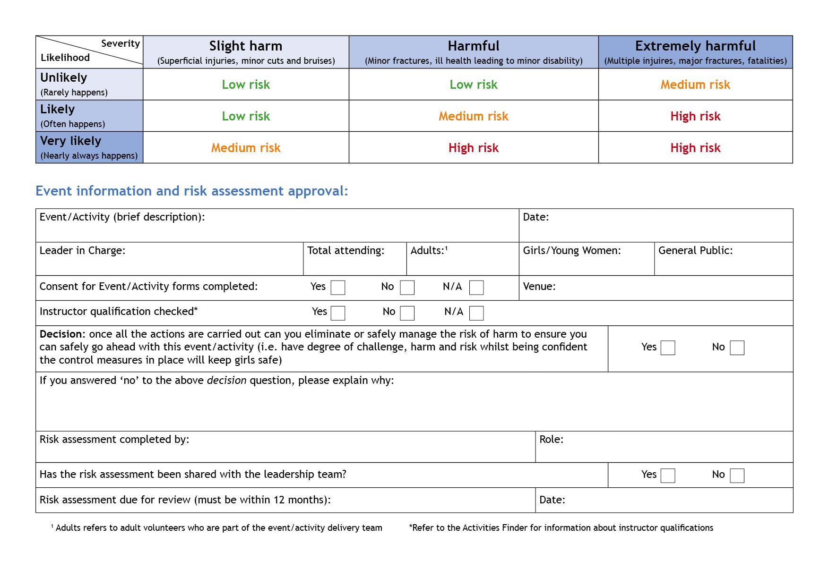
x
This is an example risk assessment – this is partially completed with prompts designed to get you started. This should be used with the resources available on the Girlguiding website and Safe Space training.

X
12/08/2019
Unit Leader
Sheila Field
x

X

X

n/a
August 2020

Playing field at back of church
15
3
12
Sheila Field
0
Outdoor games and picnic
Hazards  What could cause harm or damage? | Who or what is at risk of being affected and how? | What are you already doing?  How have you reduced the risk already? | Likelihood of risk occurring  (L/M/H) | Severity of risk  (L/M/H) | Are further controls necessary?  What else needs to happen to reduce the risk to an acceptable level? | Action by:  name/date
Wet grass from rain | Girls and adults may slip when running or walking | Check the weather forecast beforehand and a leader to check the field before taking the girls outside. Plan an alternative indoor activity if it’s too wet. First response trained adult available | M | L | If it is too wet to use the outdoor space, then the indoor area needs to be suitable for indoor activities. | SF on the day.
Hot weather | Girls and adults may get sunburnt or feel faint from the heat | Make sure girls apply sunscreen before going outside if it is sunny. Make sure that girls don’t sit or play in full sun – identify areas of shade to take a break from the sun. Take regular breaks and have drinks available. First response trained adult available. |  |  |  | All
Collision, fall, trip | Girls and adults when playing | Keep the area clear of unnecessary or dangerous obstacles. Explain the rules of the games clearly. First response trained adult available. |  |  |  | All
Strangers on site | Girls and adults – safeguarding risk | How will you restrict/manage access? Does anyone else have access to the building? Do you as leaders have a plan for emergencies like someone on site who is a concern? Have you talked to the girls about what to do? |  |  |  | All
Food and drink allergies  Have you considered food preferences for dietary or religious/cultural reasons? | Girls and adults | Who is the first aider? Do you have allergy information from parents? How will you identify food and its contents so girls know what they can eat? Who holds emergency contact details? |  |  | Do you have access to a phone for emergencies?
Bee/wasp sings | Girls or adults (consider allergic reaction to bee/wasp sting)
Girls excluded from games | Girls may be unable to take part in games (e.g. through additional needs/disability). How are you going to incorporate all girls? What reasonable adjustments can you put in place?
Fire | Girls and adults

Hazards  What could cause harm or damage? | Who or what is at risk of being affected and how? | What are you already doing?  How have you reduced the risk already? | Likelihood of risk occurring  (L/M/H) | Severity of risk  (L/M/H) | Are further controls necessary?  What else needs to happen to reduce the risk to an acceptable level? | Action by:  name/date

